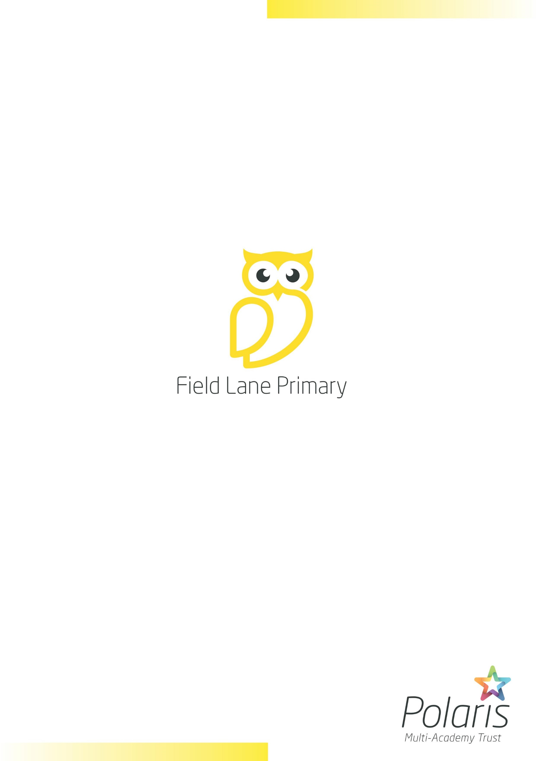

|  |  |
| --- | --- |
| Policy: | Behaviour Policy |
| Date implemented: | November 2021 |
| Date of review: | September 2024 |
| Date of next review: | September 2025 |
| Lead professional: | Head of School |
| Status: | Statutory |

|  |
| --- |
| INDEX |

|  |  |
| --- | --- |
|  | Introduction |
|  | Praise and Rewards |
|  | Consequences for Poor Behaviour |
|  | Early Years Foundation Stage (EYFS) |
|  | Children with Special Education Needs and Disability (SEND) |
|  | Behaviour outside of the formal curriculum |
|  | Mobile phones |
|  | Searching, Screening and confiscation |
|  | Monitoring and evaluation |

1. **Introduction**

Our primary school is first and foremosta place of learning, where pupils are valued and encouraged to do their personal best.We operate a positive behaviour management system that ensures children understand what kind of behaviour is acceptable in school and what the consequences of different types of behaviour might be.

The policy is central to and underpins the school’s personal development curriculum. The overriding aim of which is to support our children to become active and responsible citizens by equipping them with the life skills and personal attributes that they need for their future.

Personal Development Curriculum:

* We respect ourselves and others
* We look after and value our environment
* We follow our class community rules
* We strive to be the best version of ourselves (We are **M**otivated, we have **I**ntegrity, we are **R**espectful, **R**esilient, **O**penminded, and **R**eflective - **MIRROR**)
* We celebrate and give back to our community

1. **Praise and Rewards**

At our school we have a dedicated staff team who are committed to the implementation of this policy and in turn the building of positive and respectful relationships. Staff employ a number of different strategies to manage behaviour positively:

* Public praise and private criticism
* Catch *them* being good
* Three positives before a negative
* Acknowledge feelings
* Give *them* a choice
* Be consistent
* Model desired behaviour
* Listen to pupils
* Pre-empt the causes of disruptive behaviour
* Be aware of your practice and how your actions could impact on pupil’s responses

At our primary school our emphasis is on praising and recognising positive behaviour. We praise and reward positive behaviour in several different ways:

* Verbal Praise
* Dojos – for being **M**otivated, showing **I**ntegrity, being **R**espectful, **R**esilient, **O**pen-minded, and **R**eflective)
* Positive communication with parents
* Headteacher Award
* Fabulous Field Lane Award
* Special responsibility, privilege or trust
* Praise Assemblies – Parents invited to attend
* Community / Trust awards
* Reading Awards
* End of half term/year recognition awards

1. **Consequences for Poor Behaviour**

On occasion there are pupils who display behaviour that is at odds with our school’s policy. As part of our approach to supporting our pupils in becoming good citizens, we have in place a clear system of consequences, the aim of which is to support the pupil to reflect on their behaviour and make the right choice in the future.

Securing consistent consequences, that are used as infrequently as possible, is an essential part of our behaviour management approach. The principles upon which consequences are based upon are:

* The minimum consequence necessary
* Immediate and short-lived consequence – new start – new day
* Consistent consequences for one off or repeated actions
* Allow the pupil time for reflection of their behaviour and the affect it has on them and their classmates
* Consequences focused upon the act, not the pupil
* Teachers and support staff who clearly, calmly and consistently communicate their expectations of a pupil’s behaviour to enable the pupil has a clear understanding of why the consequence has been implemented
* Teachers and support staff who consistently model and praise acceptable behaviour

The consequences for poor behaviour choices, in the table below, are implemented when a child has been given a chance to correct their behaviour and has chosen not to do so. Consequences maybe altered according to the individual circumstances of each incident.

|  |  |
| --- | --- |
| Consequences | Sanctions |
| Warning- rule reminders  A warning can be given to an individual and/or a group/class. | ‘Pupil x you are distracting others from working. If you choose to keep talking that is a C1’ |
| C1  Continuation of negative behaviour following the warning. | ‘Pupil X you have continued to talk across the class, you are now on a C1.’  Recorded in the behaviour file by the adult dealing with the situation but no further action is required at this stage. |
| C2  Second negative behaviour | ‘Pupil X you have continued to talk you have moved onto C2.’  The pupil is issued with a 15 minutes break loss, this could be morning playtime, lunchtime or 15 minutes in the playground. During this time the pupil is encouraged to reflect on what they have done and what they could do differently. |
| C2  3 times C1 incidents | When a pupil has received 3 x C1 they will be issued with a C2- as above |
| C3  Third negative behaviour | ‘Pupil X you are on the verge of leaving the lesson because you are not behaving reasonably and following my guidance.’    Parents informed via Parent to text messaging service. Pupil misses lunchtime break. During this time the child is encouraged to reflect on what they have done and what they could do differently.  They receive ‘time in’ with a adult.    If a situation cannot be de-escalated, then sanctions under C4 will be implemented to prevent harm.    Once a pupil has received 3 C3’s an SLT member will need to speak to the pupil and parent/carer. A target chart may be put into place at this stage. |
| C4  Consistent episodes of negatives behaviours  Immediate C4 for health and safety | A C4 can only be given when a pupil has worked their way through the consequences or immediately for health and safety.    An internal exclusion used to deescalate the situation and prevent the conclusion of the behaviours. Parents informed by telephone. |
| C5  Immediate threat to others | If there is a situation that warrants suspension, then a fixed term referral needs to be made. A member of SLT will issue the fixed term suspension notifying parents.    A reintegration meeting will be arranged with the pupil and parent/carer following the fixed term exclusion. |
| C6  Permanent exclusion | A C6 can only be given when a child has worked their way through the consequences or there is an immediate threat to other pupils or staff.  This is as a last resort and in extreme circumstances. |

In the table below are some examples of the types of behaviour associated with each type of consequence.

|  |  |
| --- | --- |
| Code | Behaviour |
| C1 | Failure to follow instructions |
| C1 | Distracting behaviour |
| C1 | Lack of effort |
| C1 | Not following school code of conduct. |
| C2 | 3 * C1 in 1 day. |
| C2 | Damage/ misuse of equipment |
| C2 | Disruptive behaviour |
| C2 | Graffiti – book or furniture |
| C2 | Aggressive or inappropriate language |
| C2 | Leaving the classroom without adult consent |
| C3 | 4 * C1 in 1 day or 2 * C2 |
| C3 | Violence towards another pupil |
| C3 | Dangerous reckless behaviour |
| C3 | Bullying incident |
| C3 | Swearing |
| C3 | Aggression to staff |
| C3 | Racism/ homophobia |
| C3 | Taking something that doesn’t belong to you. |
| C3 | Leaving the school building without consent |
| C3 | Use of a mobile phone in school time- immediate confiscation |
| C4 | Setting off fire alarm |
| C4 | Inappropriate sexual behaviour |
| C4 | Physical assault on pupil |
| C4 | Offensive weapon (possession) |
| C4 | Serious and persistent failure to comply to school code of conduct |
| C4 | Persistent targeted bullying |
| C5 | Total failure to respond to school policy |
| C5 | Offensive weapon with intent to use |
| C5 | Serious physical assault |

Consequences are currently recorded on CPOMS.

**Serious breaches of the school’s behaviour policy (C5 and C6)**

Serious breaches of the school’s behaviour policy may result in a suspension or permanent exclusion. For the vast majority of pupils, suspensions and permanent exclusions may not be necessary, as other strategies can manage their behaviour. If these approaches towards behaviour management have been exhausted, then suspensions and permanent exclusions will sometimes be necessary as a last resort. This is to ensure that other pupils and teaching staff can work in safety and are respected.

The school will always follow the Department for Education guidance on ‘Suspension and permanent exclusion from maintained schools, academies and pupil referral units in England, including pupil movement’. This guidance lays out the procedure that the Head of School, governors, the local authority, and any other statutory partners identified in the procedure must follow, when the Head of School takes the decision to suspend or permanently exclude a pupil from the school. The Behaviour Policy and the procedures required to effectively implement the policy are reviewed annually, ensuring they are in compliance with the latest guidance from the Department for Education.

The link to the full document is here <https://assets.publishing.service.gov.uk/media/66be0d92c32366481ca4918a/Suspensions_and_permanent_exclusions_guidance.pdf>

**Early Years Foundation Stage (EYFS)**

In EYFS the children learn about boundaries and expectations from the outset. Clear and simple rules and routines are established and reinforced by all staff. The positive approach to behaviour management, in line with the school’s policy is followed (see above), however consequences are age appropriate.

Once routines and rules have been established pupils who have chosen not to follow them, are given a verbal warning and move their name on the traffic light system to amber. This visual cue encourages pupils from an early age to take responsibility for their behaviour. If they repeatedly make the wrong choices, they move their name on the traffic light to red and are given time during their lunchtime play to reflect on their behaviour and what they could do differently next time.

Staff consistently encourage pupils to make the right choice in a supportive and caring manner. After the first few weeks of starting in Reception, the class teacher will contact the parent/carer of any pupil who are persistently on the time out hive, to discuss home school behaviour management strategies.

Pupils who remain on the green are provided with lots of verbal praise and pupils who display exceptional behaviour choices/ MIRROR values, may move onto the Super Star.

1. **Children with Special Educational Needs**

We pride ourselves in being an inclusive and supportive community. We recognise that we are all individuals that have different needs and have had different experiences. Supporting the mental health and well-being of all pupils is of paramount importance. We recognise that some pupils with special educational needs, may require some extra support or an alternative approach to managing their behaviour.

Individual behaviour plans will be developed for and agreed with these pupils in partnership with teaching staff, parents/carers, and outside agencies where appropriate. A review of the plan will take place each half term and will be overseen by the school SEND lead.

1. **Behaviour outside of the formal curriculum**

We believe it is important for pupils to see that playtime behaviour also plays a part in our Behaviour Policy. Pupils are rewarded for good behaviour at playtime in the same way as the formal curriculum through Dojos. We expect pupils in school to behave well at all times both in the building, in the playground and when participating in school trips and visits. Lunchtime staff can record any incidents on behaviour slips and pass to the teacher at end of lunchtime.

1. **Mobile Phones- handed in on arrival**

At Field Lane Primary School we operate a hand in on arrival policy, in relation to mobile phones. Pupils who may be travelling too and from school independently, may require access to their mobile phone before and after school.

School does not permit any use of mobile phones throughout the school day.

On entry to the school each pupil should switch off and hand their device into the school office, where it will be stored securely throughout the day. There are then collected from the school office at the end of the school day.

Any pupil found with a mobile phone in possession during the school day will have their phone confiscated and a C3 issued. The first time a pupil has their mobile confiscated, they will be permitted to collect their device at the end of the day from the school office. In all subsequent instances, parent/care will be notified and will be requested to collect the device from school.

(See appendix A for Mobile Phone rules- Parents/carer/pupils contract)

1. **Searching, Screening and confiscation.**

The school will always act, in accordance with government guidance and its Searching, Screening and Confiscation Policy, in doing so the school will conduct searches of pupils using the following principles:

A. Staff members have the power to search pupils for any item if the pupil agrees, under the common law (paragraph 4 of the DfE guidance).

B. Only the Head of School and members of staff authorised by the Head of School have the power to search a pupil for a prohibited or banned item, regardless of whether the pupil agrees (sections 550ZA and 550ZB of the Education Act 1996, and paragraph 10 in the guidance). See below for a list of prohibited items.

C. These members of staff are: Caroline Howarth (Head of School),Gemma Brook (Assistant Headteacher), Sarah Riley (Assistant Headteacher) and Aimee Pidgeon (Pastoral Lead).

D. The member of staff carrying out the search will always be the same sex as the pupil and there will always be another member of staff present when the search is taking place.

E. The only exception to the point D is if the Head of School reasonably believes that there is a risk of serious harm being caused to a person if a search isn’t carried out urgently.

A search can play a vital role in identifying pupils who may benefit from early help or a referral to the local authority children’s social care services. The school’s designated safeguarding lead (DSL) will make an immediate referral if they find evidence that pupils are at risk of harm. The school will always consider reasonable grounds before a search takes place. These reasonable grounds include:

• Hear the pupil or other pupils talking about an item.

• Be told directly of an item by a pupil, member of staff or a member of the public.

• A member of staff has seen an item.

• Notice a pupil behaving in a way that causes you to suspect that they’re concealing an item.

• Observations made via CCTV.

Prohibited Items:

• Knives or weapons

• Alcohol

• Illegal drugs

• Stolen items

• Tobacco and cigarette papers

• Fireworks

• Pornographic images

• Drinks with high levels of caffeine

• Any article that the member of staff reasonably suspects has been, or is likely to be, used to:

o Commit an offence

o Cause personal injury (including the pupil) or damage to property

The complete Searching, Screening and Confiscation Policy is available on request from school reception.

1. **Monitoring and evaluation**

All staff throughout the school will be responsible for monitoring behaviour, however the Head of School, Senior Leadership Team will also use contextual information (e.g. age, gender, SEN, ethnicity, etc.) when monitoring and evaluating behaviour, which will be reported to the Trust each term.

The Local Governing Body (LGB) will conduct an annual review of this policy.

**Appendix 1-** **Mobile phone rules- Parents/carers/pupils contract**

Whilst we acknowledge parents/carers right to allow their child to bring a mobile phone to school, for safety reasons, **Field Lane Primary School discourages pupils from bringing one to school.**

1. Only pupils who have written permission from their parents/carers are entitled to bring mobile phones to school. **We advise parents/carers to only request permission for pupils who walk to and from school without an adult. Please complete the attached permission slip if you wish your child to bring his/her mobile phone to school and return the slip to the school office.**
2. If pupils bring a mobile phone to school, *the phone must be switched off on entry.*
3. Pupils must hand their mobile phones to the school office admin on arrival at school.
4. Pupils’ mobile phones will be kept locked away until the end of the school day.
5. Mobile phones seen in class during the school day will be confiscated immediately by a member of staff until the end of the day. On any further occasions of a breach of this policy, it will be the responsibility of the parent/carer to collect the phone from school, not the pupil.
6. **The school cannot be held responsible for the security of pupils’ mobile phones at any time.**

…………………………………………………………………………………………………………………….

**Mobile Phone Permission Slip**

Name of Child:____________________________________Class:___________

My child needs to bring a mobile phone to school as he/she walks to/from school without an adult.

I accept that the school cannot be held responsible for the security of my child’s mobile phone and understand that if the phone is used inappropriately at the school, the phone will be confiscated immediately, and I will be responsible for collecting it from school.

Signature of Parent / Carer:___________________________________________

Date: _____________________________________________________________